Mini Project Report
Food Meter
A Calorie & Nutrition Tracking Web Application

Programme | S.Y.B.Sc. (Computer Science)
Semester | IV
Course Code | CS-281-FP
Course Title | Mini Project
Submitted by: _Anushka Pasalkar / Nisha Wankhedkar
Roll No:- 57 / 79
Academic Year: 2025 - 2026
Deployment Link: https://github.com/anushkapasalkar746/Foodmeter.git

1. Project Overview
Food Meter is a full-stack web application developed using Python (Flask) as the backend framework and PostgreSQL as the relational database. It allows users to register, log daily food intake, track macronutrients (calories, protein, carbs, fats), monitor water consumption, compare progress with other users via a leaderboard, and export their food history as a CSV file. The frontend uses plain HTML/CSS with Chart.js for interactive visualizations.

Key Features
Feature | Description
User Auth | Registration & Login with hashed passwords (werkzeug)
Dashboard | Daily food log, macro totals, calorie goal, doughnut & weekly line charts
Meal Builder | Autocomplete food search, build a multi-item meal and log it at once
Profile | BMR calculator (Mifflin-St Jeor) to auto-set calorie goal
Food Library | Searchable encyclopedia of foods with nutritional info
Water Tracker | Logs daily water intake with animated bottle visualization
Analytics | 7-day average calories, heaviest meal, CSV export
Community Feed | Share daily intake with all users
Leaderboard | Ranks all users by closeness to their daily calorie goal

2. Database Schema (SQL)
The following SQL script creates all required tables in the PostgreSQL database food_meter_db.
-- Database: food_meter_db

CREATE TABLE users (
id SERIAL PRIMARY KEY,
name VARCHAR(100) NOT NULL,
email VARCHAR(150) UNIQUE NOT NULL,
password TEXT NOT NULL,
daily_goal INTEGER DEFAULT 2000,
weight_kg NUMERIC(5,2),
height_cm NUMERIC(5,2),
age INTEGER,
gender VARCHAR(10)
);

CREATE TABLE food_library (
id SERIAL PRIMARY KEY,
food_name VARCHAR(200) NOT NULL,
calories NUMERIC(8,2) DEFAULT 0,
protein NUMERIC(8,2) DEFAULT 0,
carbs NUMERIC(8,2) DEFAULT 0,
fats NUMERIC(8,2) DEFAULT 0,
minerals TEXT
);

CREATE TABLE food_entries (
id SERIAL PRIMARY KEY,
user_id INTEGER REFERENCES users(id) ON DELETE CASCADE,
food_name VARCHAR(200) NOT NULL,
quantity VARCHAR(100),
calories NUMERIC(8,2) DEFAULT 0,
protein NUMERIC(8,2) DEFAULT 0,
carbs NUMERIC(8,2) DEFAULT 0,
fats NUMERIC(8,2) DEFAULT 0,
minerals TEXT,
entry_date DATE DEFAULT CURRENT_DATE
);

CREATE TABLE community_posts (
id SERIAL PRIMARY KEY,
user_id INTEGER REFERENCES users(id) ON DELETE CASCADE,
user_name VARCHAR(100),
meal_name VARCHAR(200),
total_calories NUMERIC(8,2),
posted_at TIMESTAMP DEFAULT NOW()
);

CREATE TABLE water_logs (
id SERIAL PRIMARY KEY,
user_id INTEGER REFERENCES users(id) ON DELETE CASCADE,
amount_ml INTEGER DEFAULT 0,
log_date DATE DEFAULT CURRENT_DATE,
UNIQUE (user_id, log_date)
);

3. Python Backend — app.py
Flask application handling routing, authentication, database operations, and API endpoints.
from flask import Flask, render_template, request, redirect, url_for, session, flash, jsonify
from werkzeug.security import generate_password_hash, check_password_hash
import psycopg2
from psycopg2.extras import RealDictCursor
from datetime import date
import csv
from io import StringIO
from flask import Response

app = Flask(__name__)
app.secret_key = "secret_key_for_session"

def get_db_connection():
return psycopg2.connect(
host="localhost", database="food_meter_db",
user="postgres", password="root123"
)

@app.route('/api/weekly_stats')
def weekly_stats():
if 'user_id' not in session:
return jsonify([])
conn = get_db_connection()
cur = conn.cursor(cursor_factory=RealDictCursor)
cur.execute("""
SELECT entry_date, SUM(calories) as total_cal
FROM food_entries
WHERE user_id = %s AND entry_date > CURRENT_DATE - INTERVAL '7 days'
GROUP BY entry_date ORDER BY entry_date ASC
""", (session['user_id'],))
stats = cur.fetchall()
cur.close(); conn.close()
return jsonify([{'day': s['entry_date'].strftime('%a'),
'calories': s['total_cal']} for s in stats])

@app.route('/')
def index():
return redirect(url_for('dashboard')) if 'user_id' in session \
else redirect(url_for('login'))

@app.route('/register', methods=['GET', 'POST'])
def register():
if request.method == 'POST':
name, email = request.form['name'], request.form['email']
pw = generate_password_hash(request.form['password'])
conn = get_db_connection(); cur = conn.cursor()
try:
cur.execute(
"INSERT INTO users (name, email, password) VALUES (%s,%s,%s)",
(name, email, pw))
conn.commit()
return redirect(url_for('login'))
except:
flash("Email already exists!")
finally:
cur.close(); conn.close()
return render_template('register.html')

@app.route('/login', methods=['GET', 'POST'])
def login():
if request.method == 'POST':
conn = get_db_connection()
cur = conn.cursor(cursor_factory=RealDictCursor)
cur.execute("SELECT * FROM users WHERE email = %s",
(request.form['email'],))
user = cur.fetchone()
cur.close(); conn.close()
if user and check_password_hash(user['password'],
request.form['password']):
session.update({'user_id': user['id'],
'user_name': user['name']})
return redirect(url_for('dashboard'))
flash("Invalid Credentials")
return render_template('login.html')

@app.route('/dashboard')
def dashboard():
if 'user_id' not in session:
return redirect(url_for('login'))
conn = get_db_connection()
cur = conn.cursor(cursor_factory=RealDictCursor)
cur.execute("SELECT name, daily_goal FROM users WHERE id = %s",
(session['user_id'],))
user_info = cur.fetchone()
cur.execute("SELECT * FROM food_entries WHERE user_id=%s AND entry_date=%s",
(session['user_id'], date.today()))
entries = cur.fetchall()
cur.execute("""SELECT SUM(calories) as cal, SUM(protein) as prot,
SUM(carbs) as carb, SUM(fats) as fat
FROM food_entries WHERE user_id=%s AND entry_date=%s""",
(session['user_id'], date.today()))
raw = cur.fetchone()
totals = {k: raw[k] if raw[k] else 0 for k in ('cal','prot','carb','fat')}
cur.close(); conn.close()
return render_template('dashboard.html', entries=entries,
totals=totals, user_info=user_info)

@app.route('/add_food', methods=['POST'])
def add_food():
d = request.form
conn = get_db_connection(); cur = conn.cursor()
cur.execute("""INSERT INTO food_entries
(user_id,food_name,quantity,calories,protein,carbs,fats,minerals)
VALUES (%s,%s,%s,%s,%s,%s,%s,%s)""",
(session['user_id'], d['food_name'], d['quantity'],
d['calories'] or 0, d['protein'] or 0,
d['carbs'] or 0, d['fats'] or 0, d['minerals']))
conn.commit(); cur.close(); conn.close()
return redirect(url_for('dashboard'))

@app.route('/delete/<int:id>')
def delete_entry(id):
conn = get_db_connection(); cur = conn.cursor()
cur.execute("DELETE FROM food_entries WHERE id=%s AND user_id=%s",
(id, session['user_id']))
conn.commit(); cur.close(); conn.close()
return redirect(url_for('dashboard'))

@app.route('/update_goal', methods=['POST'])
def update_goal():
conn = get_db_connection(); cur = conn.cursor()
cur.execute("UPDATE users SET daily_goal=%s WHERE id=%s",
(request.form.get('daily_goal'), session['user_id']))
conn.commit(); cur.close(); conn.close()
return redirect(url_for('dashboard'))

@app.route('/logout')
def logout():
session.clear()
return redirect(url_for('login'))

@app.route('/api/suggest_food')
def suggest_food():
q = request.args.get('q', '')
if len(q) < 2: return jsonify([])
conn = get_db_connection()
cur = conn.cursor(cursor_factory=RealDictCursor)
cur.execute("""SELECT food_name, calories, protein, carbs, fats
FROM food_library WHERE food_name ILIKE %s LIMIT 10""",
(f'%{q}%',))
results = cur.fetchall(); cur.close(); conn.close()
return jsonify(results)

@app.route('/library')
def library_explorer():
if 'user_id' not in session: return redirect(url_for('login'))
conn = get_db_connection()
cur = conn.cursor(cursor_factory=RealDictCursor)
cur.execute("SELECT * FROM food_library ORDER BY food_name ASC")
items = cur.fetchall(); cur.close(); conn.close()
return render_template('library.html', items=items)

@app.route('/profile', methods=['GET', 'POST'])
def profile():
if 'user_id' not in session: return redirect(url_for('login'))
conn = get_db_connection()
cur = conn.cursor(cursor_factory=RealDictCursor)
if request.method == 'POST':
w = float(request.form['weight'])
h = float(request.form['height'])
a = int(request.form['age'])
g = request.form['gender']
bmr = (10*w + 6.25*h - 5*a + 5) if g == 'male' \
else (10*w + 6.25*h - 5*a - 161)
goal = int(bmr * 1.2)
cur.execute("""UPDATE users SET weight_kg=%s, height_cm=%s,
age=%s, gender=%s, daily_goal=%s WHERE id=%s""",
(w, h, a, g, goal, session['user_id']))
conn.commit()
flash(f"Profile updated! Recommended goal: {goal} kcal")
cur.execute("SELECT * FROM users WHERE id=%s", (session['user_id'],))
user_data = cur.fetchone(); cur.close(); conn.close()
return render_template('profile.html', user=user_data)

@app.route('/community')
def community_feed():
if 'user_id' not in session: return redirect(url_for('login'))
conn = get_db_connection()
cur = conn.cursor(cursor_factory=RealDictCursor)
cur.execute("SELECT * FROM community_posts ORDER BY posted_at DESC LIMIT 20")
posts = cur.fetchall(); cur.close(); conn.close()
return render_template('community.html', posts=posts)

@app.route('/share_meal', methods=['POST'])
def share_meal():
if 'user_id' not in session: return redirect(url_for('login'))
conn = get_db_connection(); cur = conn.cursor()
cur.execute("""INSERT INTO community_posts
(user_id,user_name,meal_name,total_calories)
VALUES (%s,%s,%s,%s)""",
(session['user_id'], session['user_name'],
request.form.get('meal_name'), request.form.get('calories')))
conn.commit(); cur.close(); conn.close()
flash("Shared with the community!")
return redirect(url_for('community_feed'))

@app.route('/leaderboard')
def leaderboard():
if 'user_id' not in session: return redirect(url_for('login'))
conn = get_db_connection()
cur = conn.cursor(cursor_factory=RealDictCursor)
cur.execute("""
SELECT u.name, u.daily_goal,
COALESCE(SUM(f.calories),0) as total_eaten,
(u.daily_goal - COALESCE(SUM(f.calories),0)) as remaining
FROM users u
LEFT JOIN food_entries f
ON u.id = f.user_id AND f.entry_date = CURRENT_DATE
GROUP BY u.id ORDER BY remaining ASC""")
rankings = cur.fetchall(); cur.close(); conn.close()
return render_template('leaderboard.html', rankings=rankings)

@app.route('/analytics')
def analytics():
if 'user_id' not in session: return redirect(url_for('login'))
conn = get_db_connection()
cur = conn.cursor(cursor_factory=RealDictCursor)
cur.execute("""SELECT AVG(daily_sum) as avg_cal FROM (
SELECT SUM(calories) as daily_sum FROM food_entries
WHERE user_id=%s AND entry_date > CURRENT_DATE - INTERVAL '7 days'
GROUP BY entry_date) s""", (session['user_id'],))
avg_cal = cur.fetchone()['avg_cal'] or 0
cur.execute("""SELECT food_name, calories FROM food_entries
WHERE user_id=%s ORDER BY calories DESC LIMIT 1""",
(session['user_id'],))
heavy_meal = cur.fetchone(); cur.close(); conn.close()
return render_template('analytics.html',
avg_cal=round(avg_cal,1), heavy_meal=heavy_meal)

@app.route('/export_csv')
def export_csv():
if 'user_id' not in session: return redirect(url_for('login'))
conn = get_db_connection()
cur = conn.cursor(cursor_factory=RealDictCursor)
cur.execute("""SELECT entry_date, food_name, calories, protein, carbs, fats
FROM food_entries WHERE user_id=%s
ORDER BY entry_date DESC""", (session['user_id'],))
rows = cur.fetchall(); cur.close(); conn.close()
si = StringIO(); cw = csv.writer(si)
cw.writerow(['Date','Food Name','Calories','Protein','Carbs','Fats'])
for r in rows:
cw.writerow([r['entry_date'], r['food_name'], r['calories'],
r['protein'], r['carbs'], r['fats']])
return Response(si.getvalue(), mimetype="text/csv",
headers={"Content-disposition":"attachment; filename=food_log.csv"})

@app.route('/water', methods=['GET', 'POST'])
def water_station():
if 'user_id' not in session: return redirect(url_for('login'))
conn = get_db_connection()
cur = conn.cursor(cursor_factory=RealDictCursor)
if request.method == 'POST':
amount = int(request.form.get('amount', 250))
cur.execute("""INSERT INTO water_logs (user_id, amount_ml, log_date)
VALUES (%s,%s,CURRENT_DATE)
ON CONFLICT (user_id, log_date)
DO UPDATE SET amount_ml = water_logs.amount_ml + EXCLUDED.amount_ml""",
(session['user_id'], amount))
conn.commit()
cur.execute("SELECT amount_ml FROM water_logs WHERE user_id=%s AND log_date=CURRENT_DATE",
(session['user_id'],))
res = cur.fetchone()
current_water = res['amount_ml'] if res else 0
cur.close(); conn.close()
return render_template('water.html', current_water=current_water)

if __name__ == '__main__':
app.run(debug=True)

4. HTML Templates

4.1 login.html
<!DOCTYPE html>
<html>
<head>
<link rel="stylesheet" href="/static/css/style.css">
<title>Login - Food Meter</title>
</head>
<body>
<div class="container" style="max-width:400px; margin-top:100px;">
<div class="form-section">
<h2>Login to Food Meter</h2>
{% with messages = get_flashed_messages() %}
{% if messages %}{% for m in messages %}
<p style="color:red">{{ m }}</p>
{% endfor %}{% endif %}
{% endwith %}
<form method="POST">
<input type="email" name="email" placeholder="Email" required>
<input type="password" name="password" placeholder="Password" required>
<button type="submit">Login</button>
</form>
<p>New user? <a href="/register">Register here</a></p>
</div>
</div>
</body>
</html>

4.2 register.html
<!DOCTYPE html>
<html>
<head>
<link rel="stylesheet" href="/static/css/style.css">
<title>Register - Food Meter</title>
</head>
<body>
<div class="container" style="max-width:400px; margin-top:100px;">
<div class="form-section">
<h2>Create Account</h2>
<form method="POST">
<input type="text" name="name" placeholder="Full Name" required>
<input type="email" name="email" placeholder="Email Address" required>
<input type="password" name="password" placeholder="Password" required>
<button type="submit">Register</button>
</form>
<p>Already have an account? <a href="/login">Login here</a></p>
</div>
</div>
</body>
</html>

4.3 dashboard.html (key sections)
<!DOCTYPE html>
<html lang="en">
<head>
<meta charset="UTF-8">
<title>Food Meter - Dashboard</title>
<link rel="stylesheet" href="/static/css/style.css">
<script src="https://cdn.jsdelivr.net/npm/chart.js"></script>
</head>
<body>
<div class="container">
<!-- Header with Navigation Links -->
<div style="display:flex; justify-content:space-between; align-items:center;">
<h1>Food Meter</h1>
<div>
<a href="/analytics">Insights</a> | <a href="/community">Community</a>
<a href="/leaderboard">Leaderboard</a> | <a href="/water">Hydration</a>
<a href="/profile">Profile</a> | <a href="/library">Library</a>
<a href="/logout">Logout</a>
</div>
</div>

<!-- Daily Goal Bar -->
<form action="/update_goal" method="POST">
<input type="number" name="daily_goal" placeholder="Set Goal">
<button type="submit">Update</button>
</form>

<!-- Calorie Warning Alert -->
{% if totals.cal and totals.cal > user_info.daily_goal %}
<div class="alert">Exceeded limit by {{ totals.cal - user_info.daily_goal }} kcal</div>
{% endif %}

<!-- Macro Stats Cards -->
<div class="stats-grid">
<div>Calories: {{ totals.cal }}</div>
<div>Protein: {{ totals.prot }}g</div>
<div>Carbs: {{ totals.carb }}g</div>
<div>Fats: {{ totals.fat }}g</div>
</div>

<!-- Meal Builder + Doughnut Chart -->
<div class="stats-grid">
<div class="form-section">
<h3>Meal Builder</h3>
<input type="text" id="food_search" list="food_suggestions" placeholder="Search...">
<datalist id="food_suggestions"></datalist>
<button id="btn_stage">Add to Plate</button>
<form action="/add_food" method="POST" id="meal_form">
<!-- Hidden inputs populated by JS -->
<button type="submit">Log Entire Meal</button>
</form>
</div>
<div class="chart-section">
<canvas id="macroChart"></canvas>
</div>
</div>

<!-- Today's Food Log Table -->
<table>
<thead><tr><th>Meal</th><th>Calories</th><th>Macros</th><th>Action</th></tr></thead>
<tbody>
{% for entry in entries %}
<tr>
<td>{{ entry.food_name }}</td><td>{{ entry.calories }}</td>
<td>{{ entry.protein }}g / {{ entry.carbs }}g / {{ entry.fats }}g</td>
<td><a href="/delete/{{ entry.id }}">Remove</a></td>
</tr>
{% endfor %}
</tbody>
</table>

<!-- Weekly Trend Chart -->
<canvas id="weeklyChart"></canvas>
</div>
<script>
// Doughnut chart
new Chart(document.getElementById('macroChart'), {
type: 'doughnut',
data: {
labels: ['Protein', 'Carbs', 'Fats'],
datasets: [{ data: [{{ totals.prot }}, {{ totals.carb }}, {{ totals.fat }}],
backgroundColor: ['#FF6384','#36A2EB','#FFCE56'] }]
}
});
// Weekly line chart
fetch('/api/weekly_stats').then(r => r.json()).then(data => {
new Chart(document.getElementById('weeklyChart'), {
type: 'line',
data: {
labels: data.map(d => d.day),
datasets: [{ label:'Daily Calories', data: data.map(d => d.calories) }]
}
});
});
</script>
</body>
</html>

4.4 profile.html
<!DOCTYPE html>
<html>
<head>
<link rel="stylesheet" href="/static/css/style.css">
<title>My Profile - Food Meter</title>
</head>
<body>
<div class="container" style="max-width:600px;">
<h2>Body Metrics and Goal Calculator</h2>
<div class="form-section">
<form method="POST">
<label>Weight (kg)</label>
<input type="number" name="weight" step="0.1" value="{{ user.weight_kg or '' }}" required>
<label>Height (cm)</label>
<input type="number" name="height" step="0.1" value="{{ user.height_cm or '' }}" required>
<label>Age</label>
<input type="number" name="age" value="{{ user.age or '' }}" required>
<label>Gender</label>
<select name="gender">
<option value="male" {% if user.gender=='male' %}selected{% endif %}>Male</option>
<option value="female" {% if user.gender=='female' %}selected{% endif %}>Female</option>
</select>
<button type="submit">Calculate and Save Goal</button>
</form>
</div>
{% if user.weight_kg %}
<div class="table-section">
<p>Daily target: <strong>{{ user.daily_goal }} kcal</strong> (BMR x 1.2)</p>
</div>
{% endif %}
</div>
</body>
</html>

4.5 water.html
<!DOCTYPE html>
<html lang="en">
<head>
<link rel="stylesheet" href="/static/css/style.css">
<title>H2O Station - Food Meter</title>
<style>
.bottle-container {
width:160px; height:320px; border:5px solid #1d70b8;
border-radius:15px 15px 40px 40px;
margin:40px auto; position:relative;
overflow:hidden; background:#e6f3ff;
}
.water-fill {
position:absolute; bottom:0; width:100%;
background:linear-gradient(to top,#36A2EB,#4db8ff);
transition:height 1s ease-in-out;
}
</style>
</head>
<body>
{% set goal = 2500 %}
{% set pct = (current_water / goal * 100)|round|int %}
<div class="container" style="text-align:center; max-width:500px;">
<h2>H2O Station</h2>
<p>Target: <strong>2,500 ml</strong></p>
<div class="bottle-container">
<div class="water-fill" style="height:{{ pct }}%;"></div>
</div>
<h1>{{ current_water }} ml</h1>
<p>{{ pct }}% of daily goal</p>
<form method="POST">
<input type="hidden" name="amount" value="250">
<button>+ 250 ml</button>
</form>
<form method="POST">
<input type="hidden" name="amount" value="500">
<button>+ 500 ml</button>
</form>
</div>
</body>
</html>

4.6 analytics.html
<!DOCTYPE html>
<html>
<head>
<link rel="stylesheet" href="/static/css/style.css">
<title>Analytics - Food Meter</title>
</head>
<body>
<div class="container">
<h2>Progress Insights</h2>
<div class="stats-grid">
<div class="table-section" style="text-align:center;">
<h4>7-Day Average</h4>
<p style="font-size:2rem;">{{ avg_cal }} kcal</p>
</div>
<div class="table-section" style="text-align:center;">
<h4>Highest Calorie Item</h4>
{% if heavy_meal %}
<p><strong>{{ heavy_meal.food_name }}</strong></p>
<p>{{ heavy_meal.calories }} kcal</p>
{% else %}
<p>No data yet</p>
{% endif %}
</div>
</div>
<div class="table-section" style="text-align:center; margin-top:30px;">
<h3>Download Full History</h3>
<a href="/export_csv">Download .CSV Report</a>
</div>
</div>
</body>
</html>

4.7 community.html
<!DOCTYPE html>
<html>
<head>
<link rel="stylesheet" href="/static/css/style.css">
<title>Community Feed - Food Meter</title>
</head>
<body>
<div class="container">
<h2>Community Meal Feed</h2>
{% for post in posts %}
<div class="table-section" style="border-left:5px solid #36A2EB; margin-bottom:15px;">
<div style="display:flex; justify-content:space-between;">
<strong>@{{ post.user_name }}</strong>
<small>{{ post.posted_at.strftime('%H:%M - %b %d') }}</small>
</div>
<p>Just ate: <strong>{{ post.meal_name }}</strong></p>
<span>{{ post.total_calories }} kcal</span>
</div>
{% else %}
<p>No posts yet. Be the first to share!</p>
{% endfor %}
</div>
</body>
</html>

4.8 leaderboard.html
<!DOCTYPE html>
<html>
<head>
<link rel="stylesheet" href="/static/css/style.css">
<title>Leaderboard - Food Meter</title>
</head>
<body>
<div class="container">
<h2>Daily Calorie Leaderboard</h2>
<div class="table-section">
<table>
<thead><tr>
<th>Rank</th><th>User</th><th>Progress</th><th>Status</th>
</tr></thead>
<tbody>
{% for row in rankings %}
<tr>
<td>#{{ loop.index }}</td>
<td><strong>{{ row.name }}</strong></td>
<td>{{ row.total_eaten }} / {{ row.daily_goal }} kcal</td>
<td>
{% if row.remaining < 0 %}
<span style="color:red;">Over Limit!</span>
{% else %}
<span style="color:green;">{{ row.remaining }} left</span>
{% endif %}
</td>
</tr>
{% endfor %}
</tbody>
</table>
</div>
<a href="/dashboard">Back to Dashboard</a>
</div>
</body>
</html>

4.9 library.html
<!DOCTYPE html>
<html>
<head>
<link rel="stylesheet" href="/static/css/style.css">
<title>Food Encyclopedia</title>
</head>
<body>
<div class="container">
<h2>Food Encyclopedia</h2>
<input type="text" id="lib_search" placeholder="Search foods...">
<div class="stats-grid" id="food_grid">
{% for item in items %}
<div class="table-section food-card" data-name="{{ item.food_name|lower }}">
<h3>{{ item.food_name }}</h3>
<div>
<span>Calories: {{ item.calories }}</span> |
<span>Protein: {{ item.protein }}g</span> |
<span>Carbs: {{ item.carbs }}g</span> |
<span>Fats: {{ item.fats }}g</span>
</div>
<form action="/add_food" method="POST">
<input type="hidden" name="food_name" value="{{ item.food_name }}">
<input type="hidden" name="calories" value="{{ item.calories }}">
<input type="hidden" name="protein" value="{{ item.protein }}">
<input type="hidden" name="carbs" value="{{ item.carbs }}">
<input type="hidden" name="fats" value="{{ item.fats }}">
<input type="hidden" name="quantity" value="1 Portion">
<input type="hidden" name="minerals" value="Library Entry">
<button type="submit">Quick Add to Log</button>
</form>
</div>
{% endfor %}
</div>
</div>
<script>
document.getElementById('lib_search').addEventListener('input', e => {
const t = e.target.value.toLowerCase();
document.querySelectorAll('.food-card').forEach(c => {
c.style.display = c.dataset.name.includes(t) ? '' : 'none';
});
});
</script>
</body>
</html>

5. CSS — static/css/style.css
:root {
--primary: #4a90e2;
--danger: #e74c3c;
--success: #2ecc71;
--dark: #2c3e50;
--bg: #f4f7f6;
}
body {
font-family: 'Segoe UI', Tahoma, Geneva, Verdana, sans-serif;
background-color: var(--bg);
margin: 0;
color: var(--dark);
}
.container {
max-width: 1000px;
margin: 20px auto;
padding: 20px;
}
.stats-grid {
display: grid;
grid-template-columns: 1fr 1fr;
gap: 20px;
margin-bottom: 30px;
}
@media (max-width: 768px) {
.stats-grid { grid-template-columns: 1fr; }
}
.form-section, .chart-section, .table-section {
background: white;
padding: 25px;
border-radius: 12px;
box-shadow: 0 4px 6px rgba(0,0,0,0.1);
}
.chart-section {
display: flex;
align-items: center;
justify-content: center;
min-height: 300px;
}
input, button {
width: 100%;
padding: 12px;
margin: 8px 0;
border: 1px solid #ddd;
border-radius: 6px;
box-sizing: border-box;
}
button {
background-color: var(--primary);
color: white;
border: none;
cursor: pointer;
font-weight: bold;
transition: background 0.3s;
}
button:hover { background-color: #357abd; }
.alert {
background-color: #ffeaea;
color: var(--danger);
padding: 15px;
border-radius: 8px;
border-left: 5px solid var(--danger);
margin-bottom: 20px;
}
table { width:100%; border-collapse: collapse; margin-top: 20px; }
th, td { text-align: left; padding: 15px; border-bottom: 1px solid #eee; }
th { background-color: #f8f9fa; }
.btn-delete { color: var(--danger); text-decoration: none; font-weight: bold; }

6. Screenshots — Input and Output Screens
Replace each placeholder box below with an actual screenshot of the running application before submission.

Input Screen 1 — Login Page
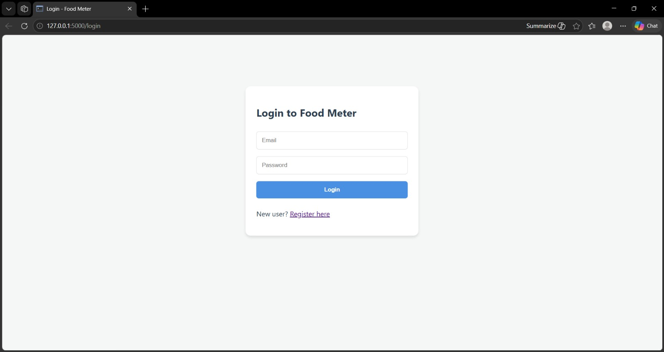
Shows the login form with email and password fields.
Input Screen 2 — Register Page
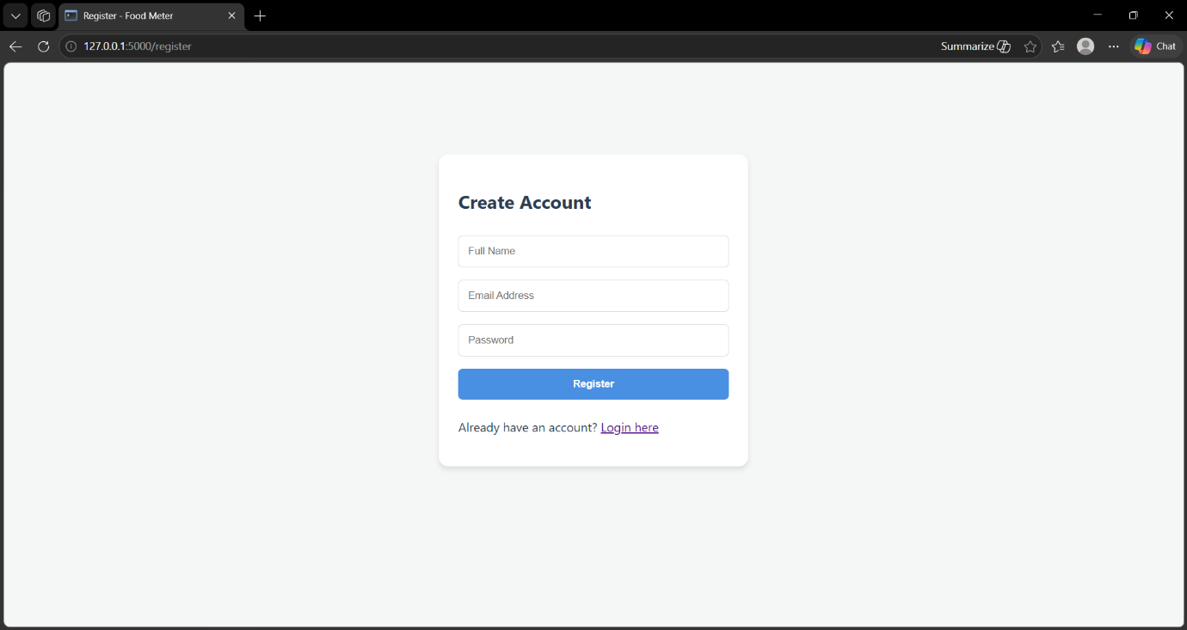
Shows the registration form for new users.
Input Screen 3 — Das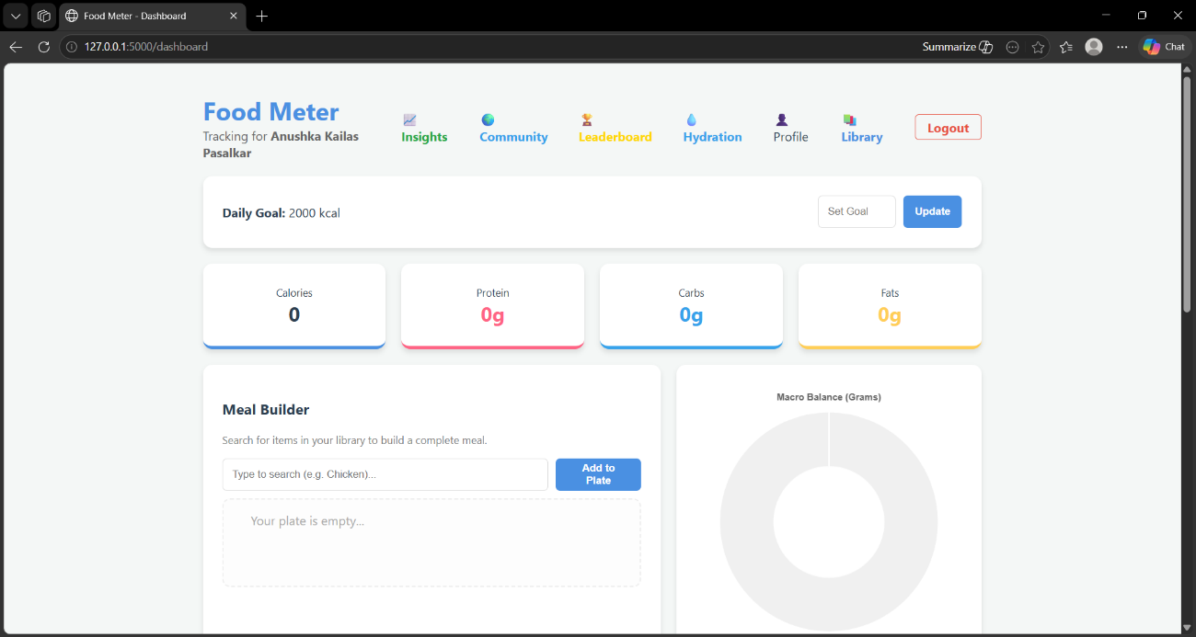hboard: Meal Builder
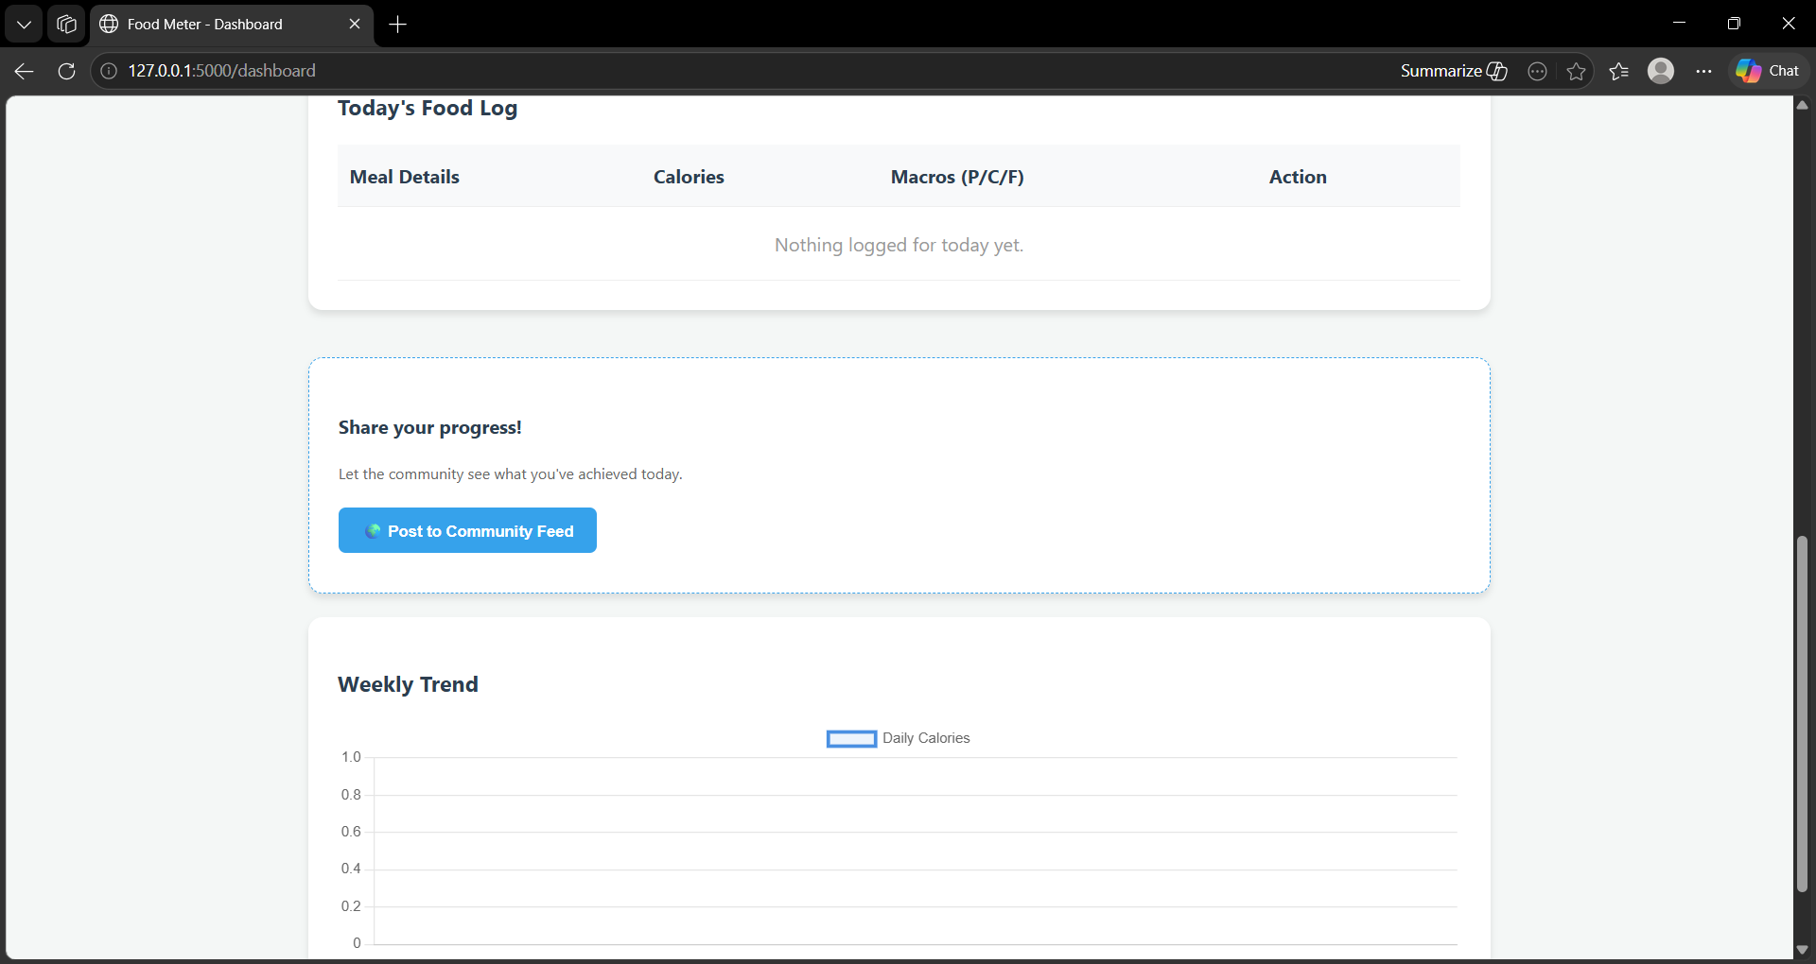
Shows the food search input and Add to Plate button.
Input Screen 4 — Profile: BMR Calculator
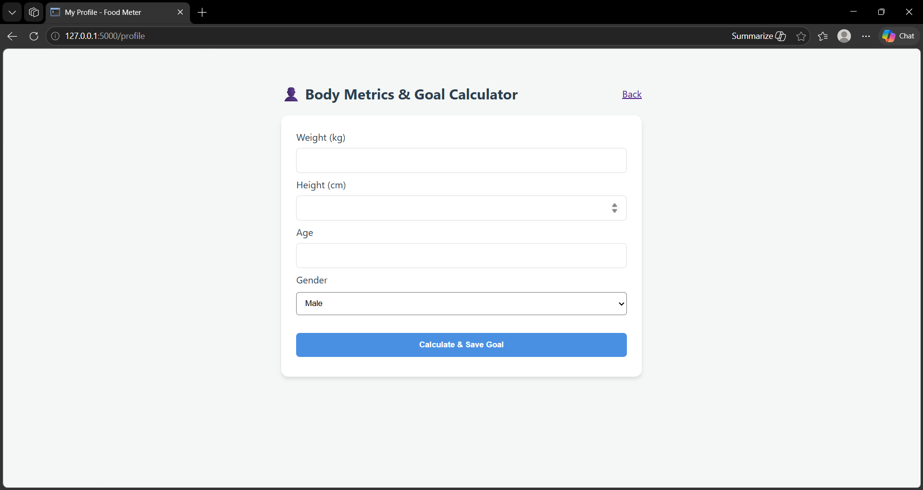
Shows the body metrics form for weight, height, age, gender.
Input Screen 5 — Water Tracker: Log Water
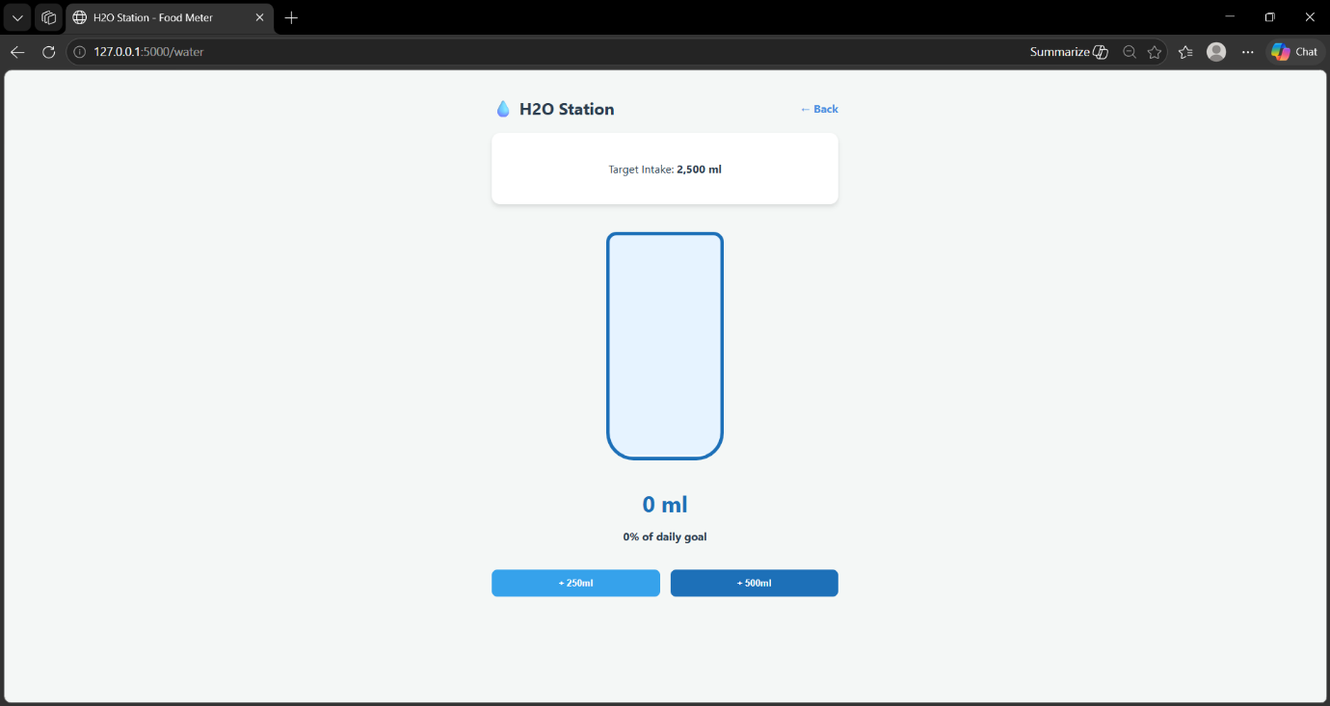
Shows the +250ml / +500ml water logging buttons.
Output Screen 1 — Dashboard: Daily Summary
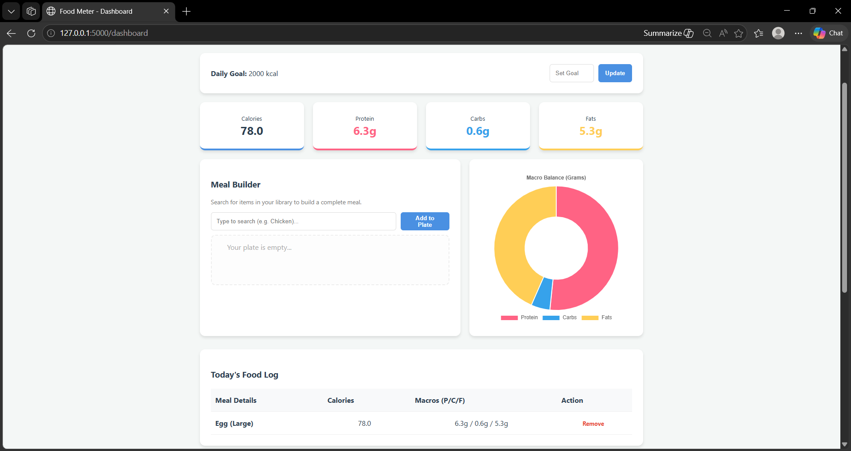
Shows calorie totals, macro cards, and the doughnut chart.
Output Screen 2 — Dashboard: Weekly Chart
]
Shows the weekly calories line chart.
Output Screen 3 — Food Library / Encyclopedia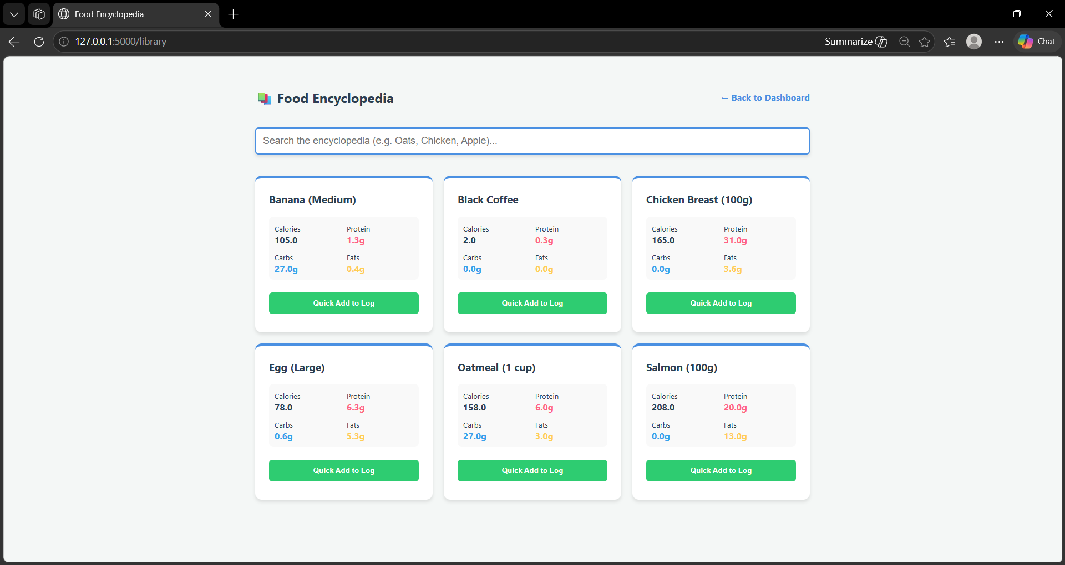

Shows the searchable grid of food items with nutritional info.
Output Screen 4 — Analytics / Insights
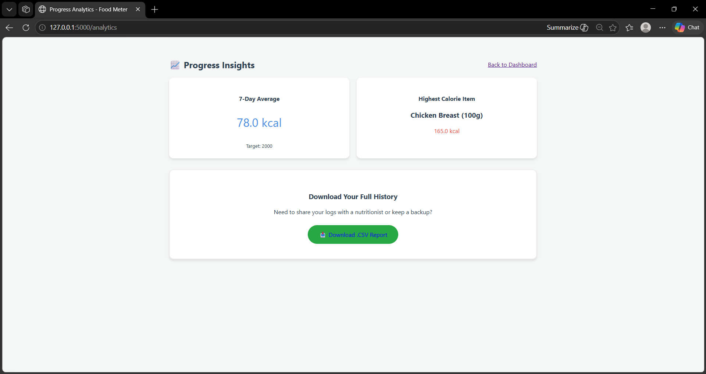
Shows 7-day average, heaviest meal, CSV export button.
Output Screen 5 — Community Feed
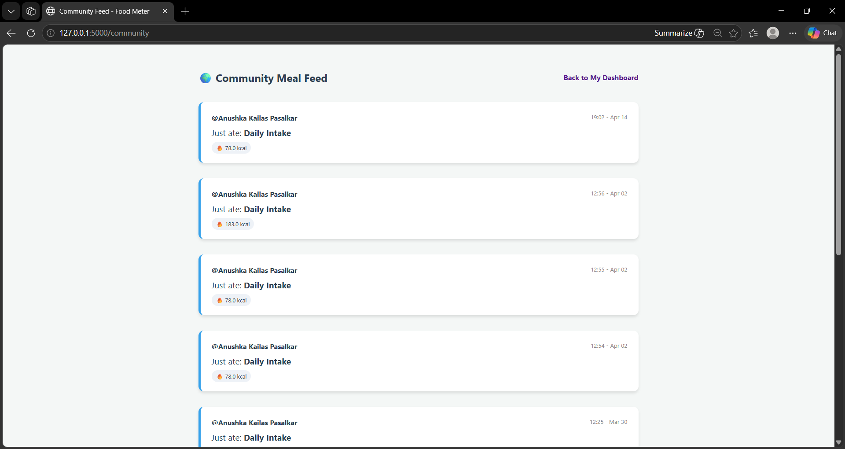
Shows shared meal posts from all users.
Output Screen 6 — Leaderboard
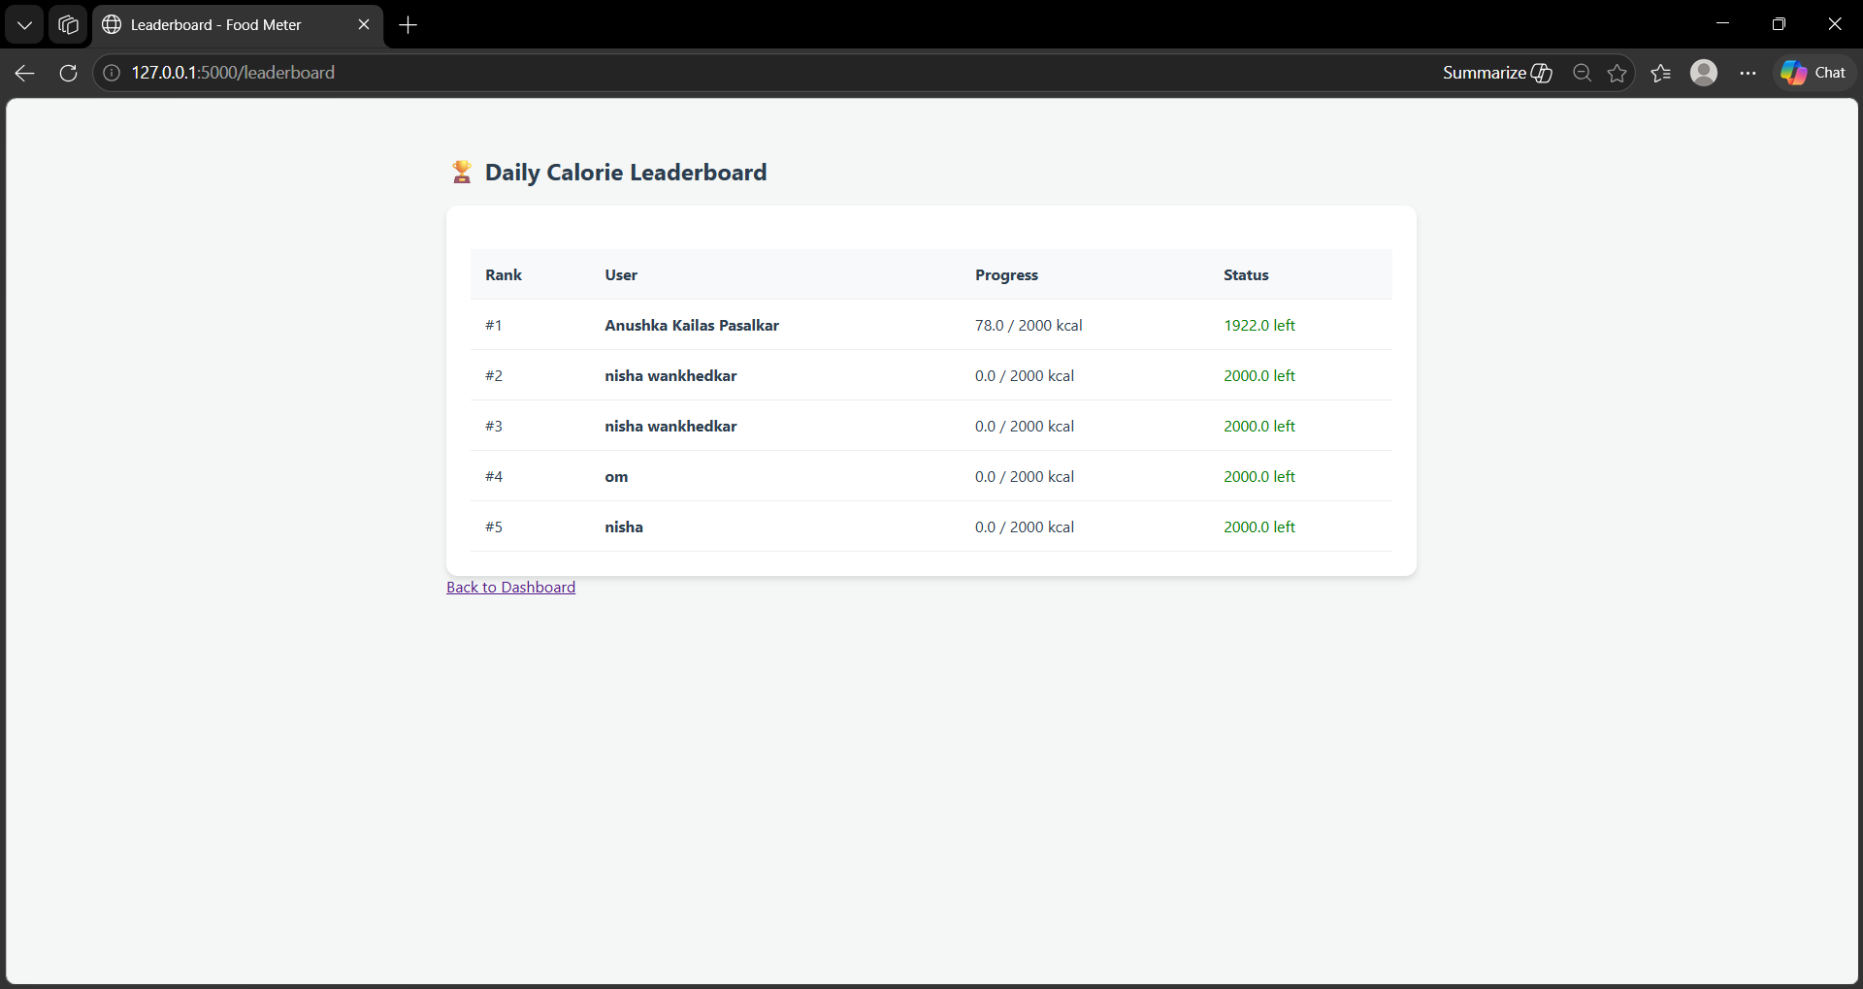
Shows ranked table of users by daily calorie progress.
Output Screen 7 — Water Station (Filled) 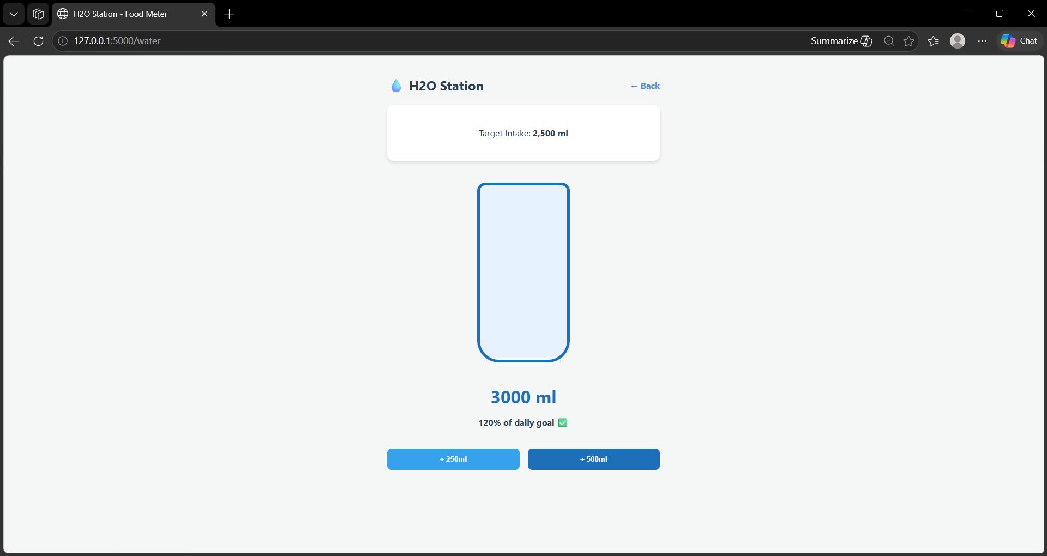

Shows the animated water bottle with current ml logged.

